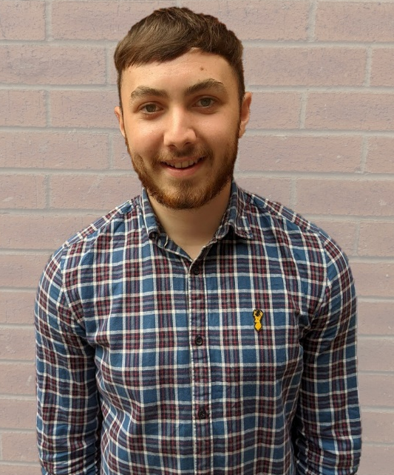
Domhnall McKinney – Graduate Java Developer

What is your background and how did you come about joining AquaQ?
I have always been interested in tech and software throughout school and decided to study ICT at Northwest Regional College. After completing my level 3 extended diploma in ICT, I went on to study Computer Science at Liverpool John Moore's University. After graduating I joined AquaQ as a Graduate Java Developer and have thoroughly enjoyed working and learning alongside the AquaQ team.

What attracted you to join AquaQ?
I was attracted to join AquaQ as I was interested in working in the financial tech industry and was intrigued by their ever-expanding global client base of investment banks and hedge funds as it would allow me to continue learning and working with the best industry standard technologies and practices.

What is your typical day like?
My typical day I will sign on for 9 am and have a scrum call with my team. We will let each other know what we had worked on yesterday and what we plan to work on today. If I have any questions regarding what I will be working on today I will say so in scrum and I will hop on a call with another developer after scrum to get the answers I need. If I have any problems or questions throughout the day I will simply message the team or another developer who will happily help me which is great so that I am never stuck on anything for more than 5 mins. There may be a call scheduled with the business throughout the day or with one of the business analysts to devise the requirements or pieces of work to be completed next. Work hours are flexible in that you can start at 8 and finish an hour earlier or take a shorter lunch and finish half an hour earlier which is great.

What skills are you hoping to develop as part of your team?
Working in a team and having to communicate effectively with each other and the client allows me to develop my communication and teamworking skills on a daily basis. Working with java, spring, sql and having the opportunity to learn from more senior developers has allowed me to continue developing my technical skills.

What are the benefits of being a part of the AquaQ team?
The AquaQ team is great to be a part of as everyone is extremely friendly and helpful which makes for a fun working environment that allows you to learn, interact and collaborate with others while working towards your teams’ goals. As well as social events being planned throughout the year, the ever-growing diverse team of individuals makes working for AquaQ enjoyable and meaningful.

What is the most interesting thing about working at AquaQ and the work you do?
The most interesting thing about working at AquaQ is that the projects and technology are at the forefront of the industry and the diversity of the AquaQ team, and the company culture make working here interesting.
As AquaQ are expanding they have opened an office in Derry/Londonderry and are actively recruiting within the city which is great. I look forward to meeting new team members from the city and working alongside them in the new office.

