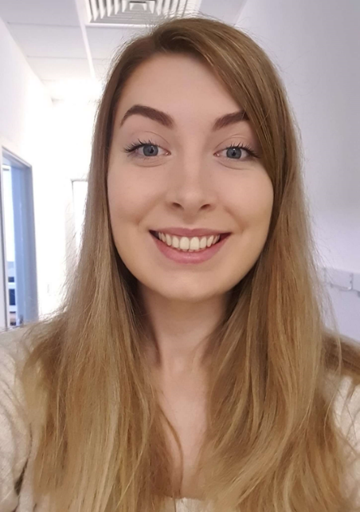
Gillian Bond – Java Developer/Line Manager

What is your background and how did you come about joining AquaQ?
My first real insight into development was during my degree in Computer Science at Ulster University Magee, I really enjoyed the programming modules and learning about software development. As a placement year was part of my degree, I spent a year as a QA Analyst, which was something that interested me at the time, and I wanted experience in.
After graduation I returned to my placement company, completed their two-year graduate scheme, and worked as a full-time developer for a further two years. During that time, I worked in three different teams, and I was exposed to Java, Kotlin, a little React and creating CI/CD pipelines.
I first interviewed for AquaQ because my role was becoming repetitive, and I didn't feel challenged. I was successful in my application, but I took another offer, a year later I joined AquaQ but for a different reason; I wanted more experience in coding as I wasn't spending enough time in my role writing code, and I think this is something AquaQ can provide.

What attracted you to join AquaQ?
Great reviews from people I used to work with who joined AquaQ.

What is your typical day like?
My typical day is working on tasks assigned by the client and occasionally demoing what I've done. I have call in the morning with my team in AquaQ to give updates and ask for any advice or help and a similar call in the afternoon with my client who are in a different time zone. I also try to spend some time out if my day training for my Java Cert.

What skills are you hoping to develop as part of your team?
I'm hoping to grow upon my Java skills by gaining experience in the usage of APIs.

What are the benefits of being a part of the AquaQ team?
I'm enjoying being part of a smaller company as there's a more relaxed feel and you can tell time has been taken to think about the growth of each person who works here, by being encouraged to complete training courses or like myself influenced into applying for a line manager role.
I'm the only Java resource for my client which is quite daunting, but AquaQ provides that extra layer of support, for example if I'm having a problem in my program and someone isn't able to help me on the client side, there will be someone with that knowledge in AquaQ or will at least be able to point me in the right direction. As there is a more relaxed atmosphere I don't feel intimidated when asking for help.

What is the most interesting thing about working at AquaQ and the work you do?
It's been interesting to learn about the system I'm working on, at the start I didn't understand a lot of it, but now it comes naturally to me, which is something I'm proud of, especially being able to build that knowledge in such a short space of time.
I'm excited that AquaQ has decided to open an office in Derry/L'Derry as it gives graduates and people who are skilled in our streams a wider choice if they live in the Northwest. I had to move from Strabane to Belfast when I was looking for placement, as there wasn't much selection locally at that time. Not to be biased or anything but there's some talented individuals in these parts, especially as we have Magee School of Computing, Engineering and Intelligent Systems on our doorstep which offers courses that help individuals embark on a career in IT.

